Task 1:
- protoc: Protocol Buffers compiler.
- --go_out=.: Generates Go structs/messages for the proto definitions in the current directory.
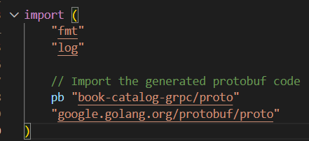
- pb "book-catalog-grpc/proto": Imports generated protobuf code with alias pb (protocol buffer)
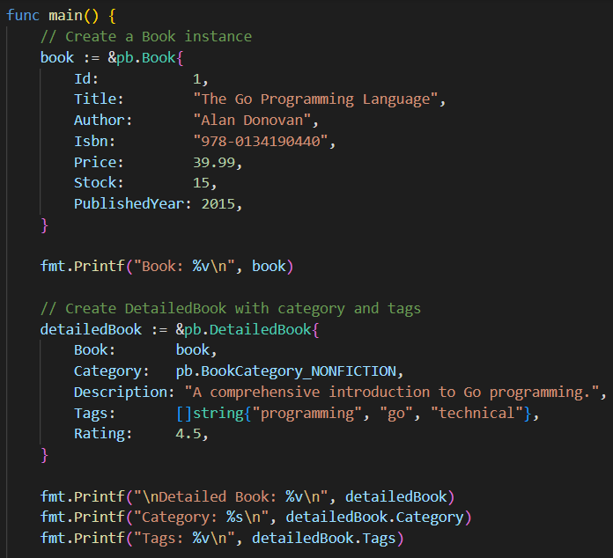
- Initializes a Book struct with fields like Id, Title, Author, ISBN, Price, Stock, and PublishedYear, then prints the struct using %v.
- Composes a DetailedBook containing a nested Book.
- Adds Category (enum), Description, Tags (string slice), and Rating.
- Prints the full struct, category, and tags.
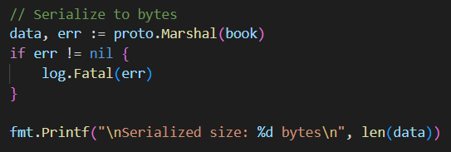
- proto.Marshal converts Book to binary bytes; prints serialized size.
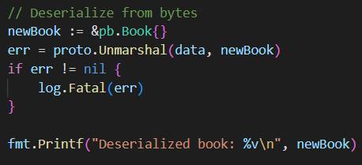
- proto.Unmarshal reconstructs a new Book from bytes; prints deserialized struct.
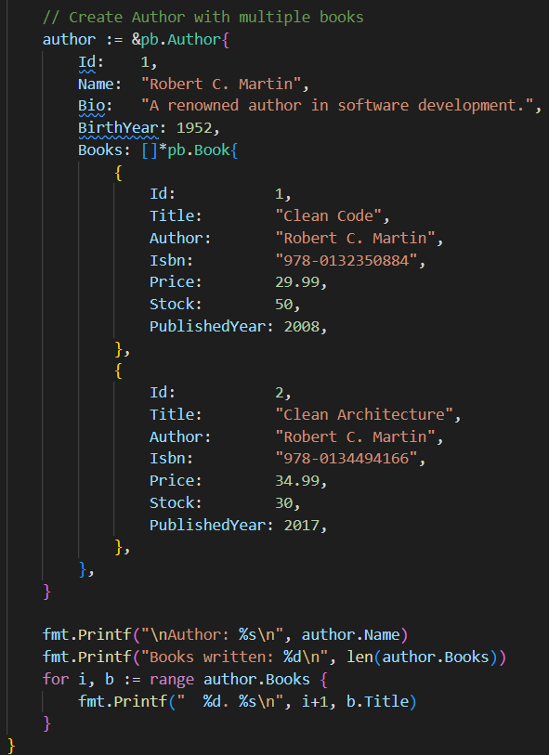
- Initializes an Author struct with Id, Name, Bio, BirthYear.
- Assigns a slice of Book pointers to demonstrate a one-to-many relationship.
- Prints author name, number of books, and a numbered list of book titles.

Output:
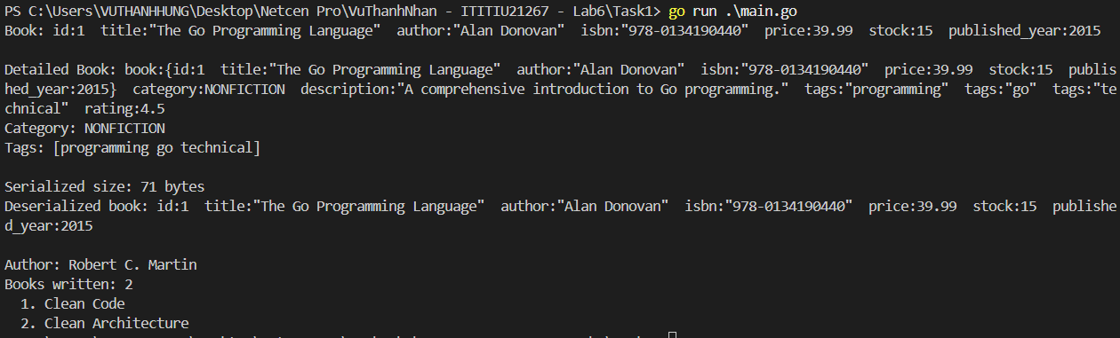

Task 2:
- protoc: Protocol Buffers compiler.
- --go_out=.: Generates Go structs/messages for the proto definitions in the current directory.
- --go-grpc_out=.: Generates Go gRPC service code (interfaces and stubs) in the current directory.

Server:
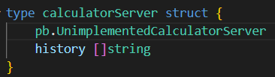
- Defines the server struct that implements the Calculator service
- pb.UnimplementedCalculatorServer: Embedding this ensures forward compatibility (if new methods are added to the proto, the code won't break)
- history []string: A slice to store calculation history in memory
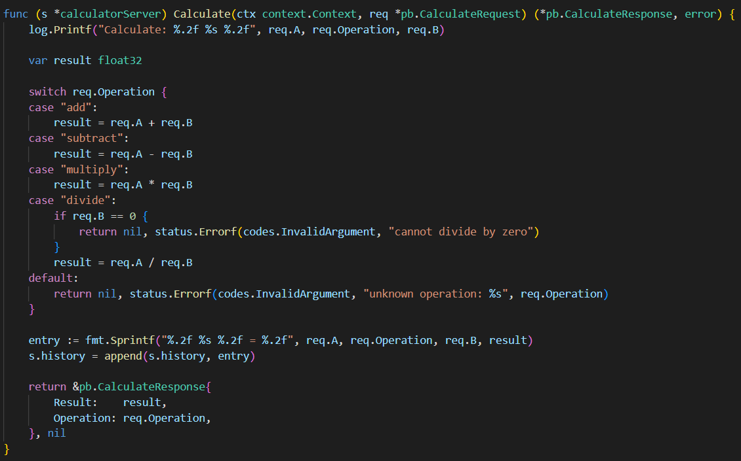
- Takes context.Context (required for all gRPC methods) and a pointer to the request; returns a pointer to the response and an error
- Logs the incoming request with 2 decimal places formatting
- Switch statement handles different operations based on the operation field
- Creates a formatted string of the calculation then appends this entry to the server's history slice
- Returns the response with the calculation result and operation
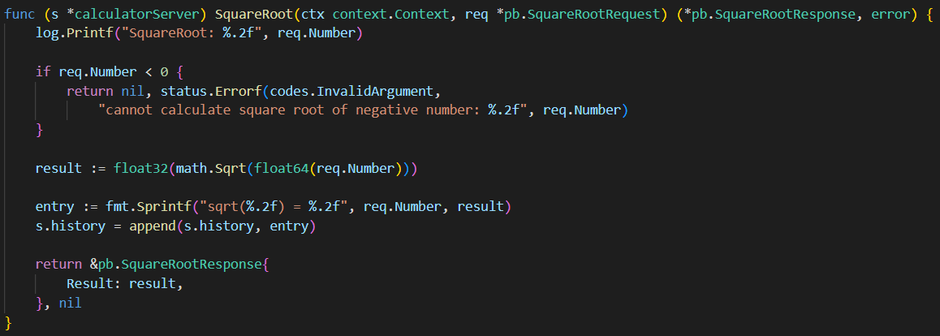
- Logs the incoming square root request
- Validates input: negative numbers don't have real square roots
- math.Sqrt() requires float64, so the number is cast to float64 for the calculation and the result is converted back to float32.
- Creates history entry and appends to history
- Returns the result wrapped in the response message
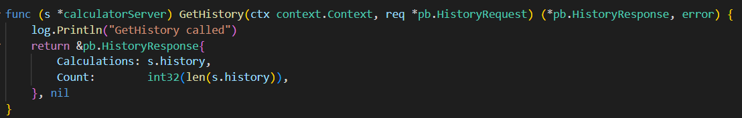
- Simple logging when history is requested and returning all stored calculations and the count.
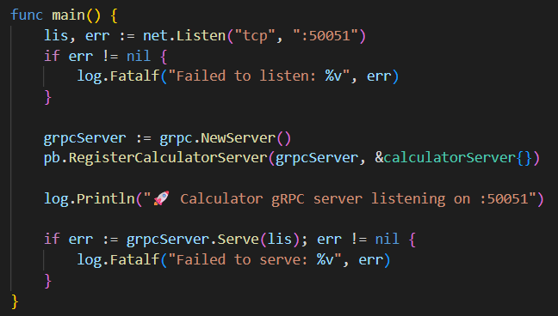
- Starts the gRPC server by creating a TCP listener on port 50051
- Initializing a new gRPC server, registering the calculatorServer implementation
- Logging that the server is running, and finally calling Serve to begin handling incoming gRPC requests.

Client:
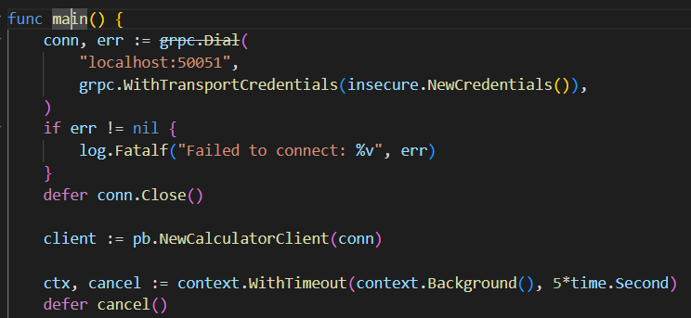
Establish Connection
- grpc.Dial("localhost:50051", grpc.WithTransportCredentials(insecure.NewCredentials())): connects to the server over an insecure channel.
- Exits with fatal error if connection fails.
- defer conn.Close(): ensures the connection closes when the program ends.
Create Client & Context
- pb.NewCalculatorClient(conn): generates a Calculator service client stub.
- context.WithTimeout(..., 5*time.Second): creates a context with a 5-second RPC timeout.
- defer cancel(): cleans up the context when finished.
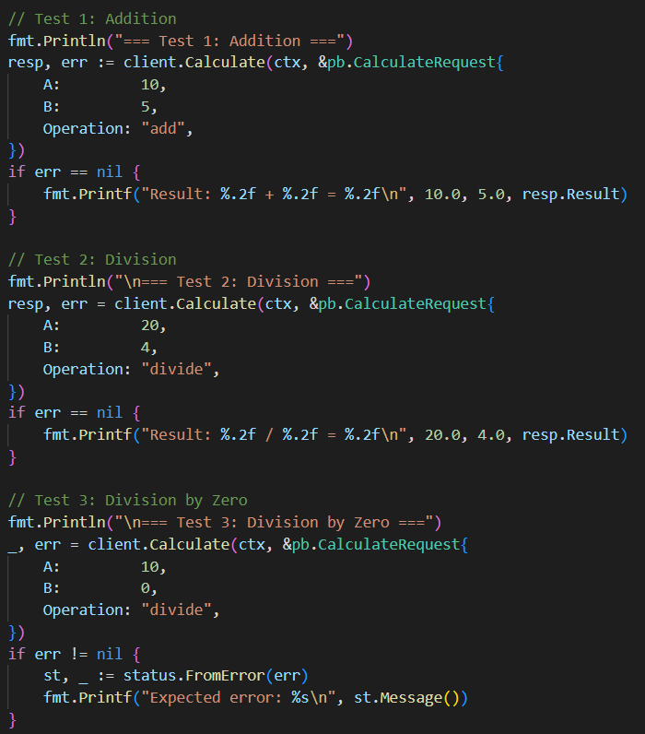
- Prints header, sends Calculate request {A:10, B:5, Operation:"add"}, and prints the formatted result if no error.
- Runs a valid division test (20 / 4), prints result, and uses the same context as previous calls.
- Sends a divide-by-zero request, expects an error, converts it to a gRPC status, and prints the server-returned message.
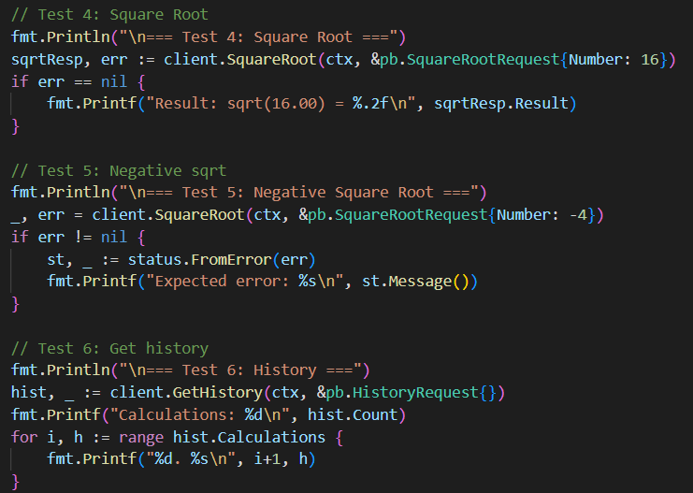
- Calls SquareRoot with 16, prints the result (expected 4.00) when successful.
- Sends a negative number to SquareRoot, receives a gRPC error, extracts and prints the error message.
- Calls GetHistory, prints the total count, and iterates through all stored calculation entries for display.

Output:
Server:
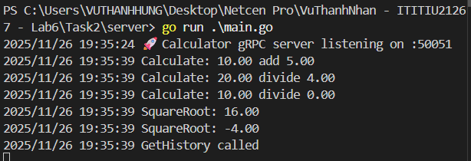
Client:
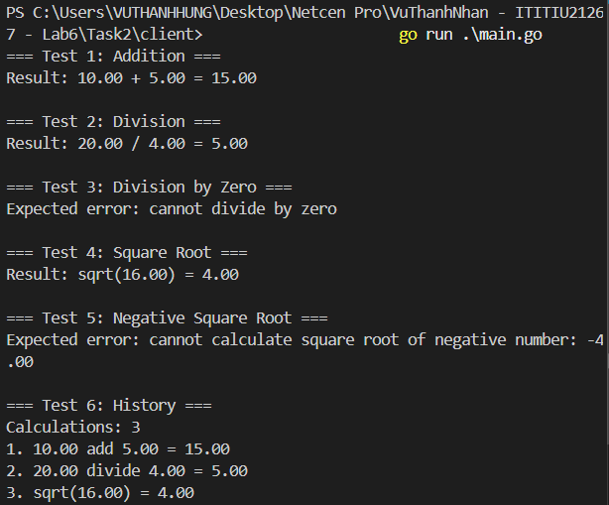

Task 3:
- protoc: Protocol Buffers compiler.
- --go_out=.: Generates Go structs/messages for the proto definitions in the current directory.
- --go-grpc_out=.: Generates Go gRPC service code (interfaces and stubs) in the current directory.
Server:
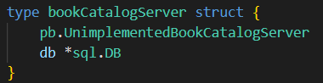
bookCatalogServer defines the gRPC server for the BookCatalog service.
- Embeds pb.UnimplementedBookCatalogServer for forward compatibility.
- Holds a *sql.DB connection shared by all RPC methods, enabling database CRUD operations.
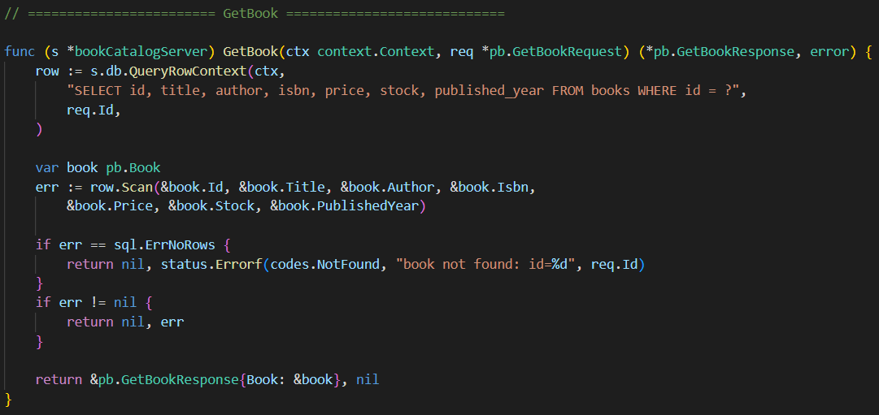
GetBook retrieves a single book by its ID.
- Executes a parameterized SQL query using QueryRowContext to safely fetch one row (ctx enables cancellation/timeout; ? prevents SQL injection).
- Scans the result into a pb.Book struct, matching the SELECT column order.
- If no row exists, returns a gRPC NotFound error; any other scan/query error is returned as-is.
- On success, wraps the populated Book in GetBookResponse and returns it.
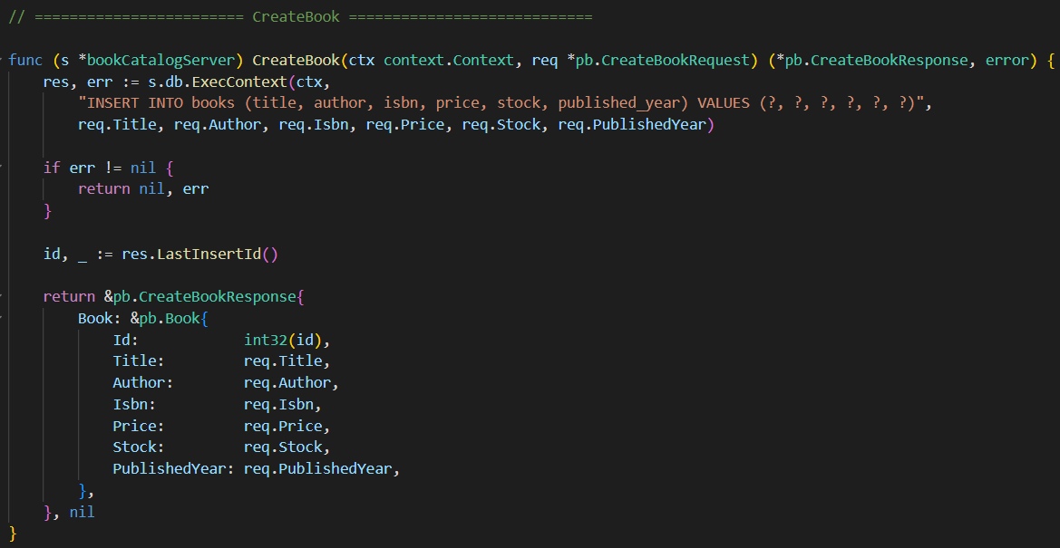
CreateBook inserts a new book into the database.
- Uses ExecContext to run an INSERT statement (no returned rows).
- Fills the six ? placeholders with the request fields; id is omitted because it’s auto-generated.
- Returns an error immediately if the insert fails.
- Retrieves the generated ID using LastInsertId and converts it to int32.
- Builds and returns a CreateBookResponse containing the newly created Book, including its assigned ID.
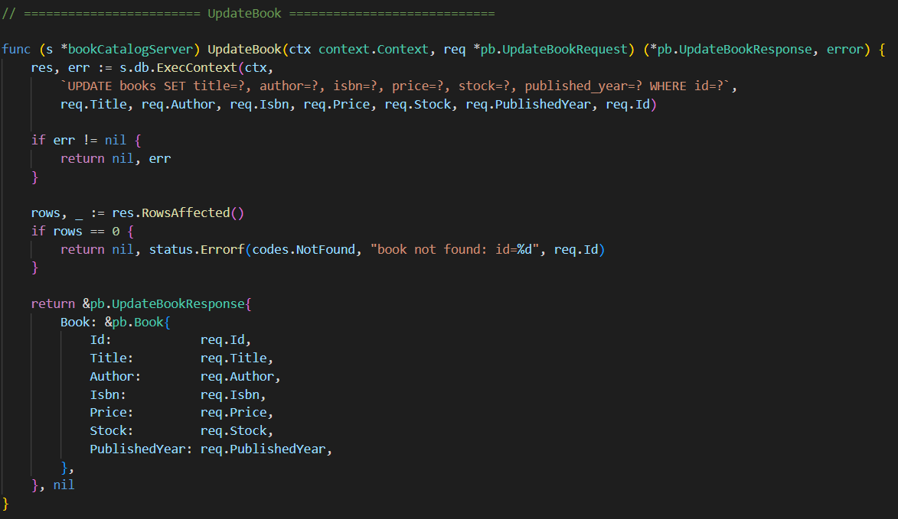
UpdateBook modifies an existing book by ID.
- Executes a parameterized UPDATE statement with seven placeholders (six fields + id).
- Returns any database errors immediately.
- Checks RowsAffected(); if zero, returns gRPC NotFound (book doesn’t exist).
- On success, returns UpdateBookResponse containing the updated book, echoing the request values.

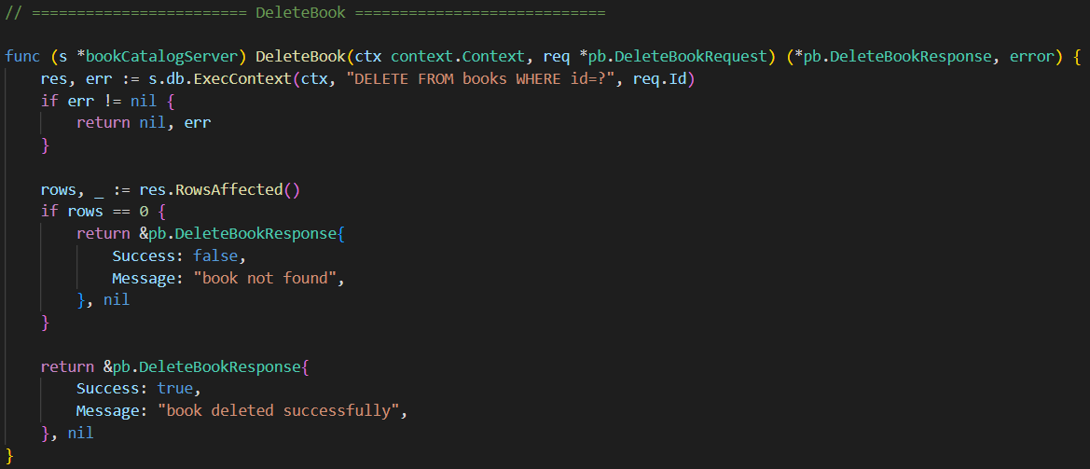
DeleteBook removes a book by ID.
- Executes a parameterized DELETE query and handles any database errors.
- Checks RowsAffected(); if zero, returns a response with Success: false and a “book not found” message (not an error).
- If a row was deleted, returns Success: true with a confirmation message.
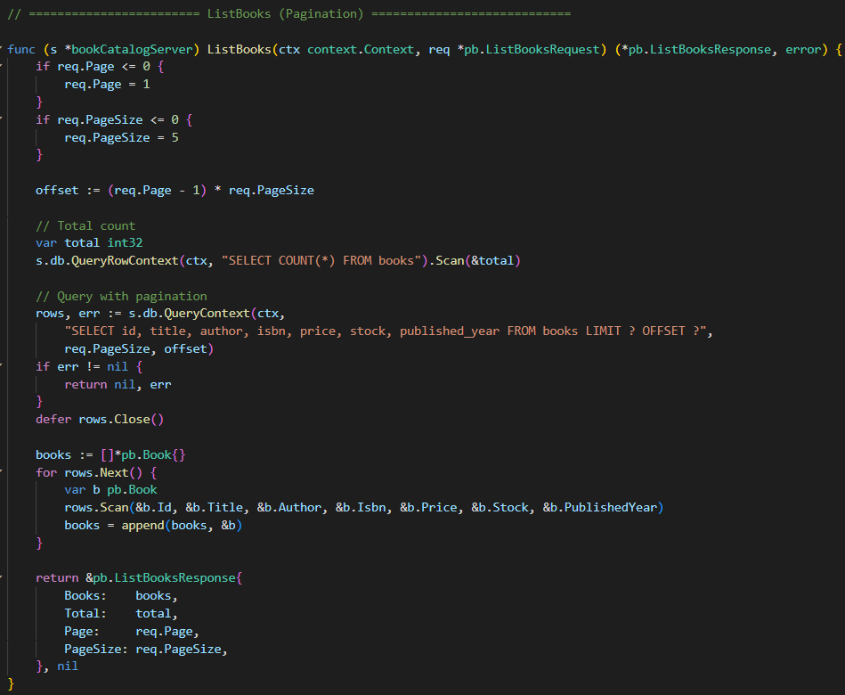
ListBooks returns a paginated list of books.
- Validates Page and PageSize, defaulting to 1 and 5 if invalid.
- Calculates offset = (Page-1) * PageSize to skip rows.
- Queries total book count for pagination info.
- Executes a parameterized SELECT with LIMIT and OFFSET to fetch the current page.
- Iterates over rows, scanning each book into a pb.Book and appending to a slice.
- Returns ListBooksResponse containing the current page’s books, total count, page number, and page size.

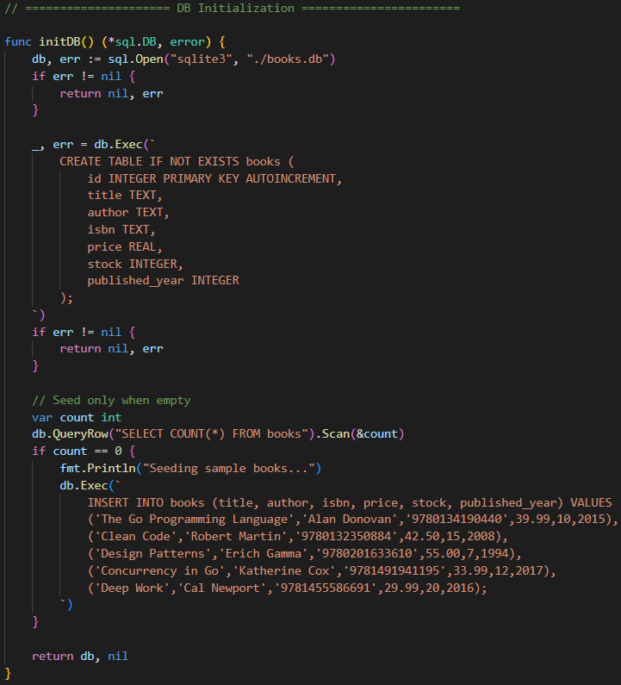
initDB initializes the SQLite database and returns a *sql.DB connection.
- Opens the SQLite database file (books.db), creating it if needed.
- Creates the books table if it doesn’t exist, defining id as auto-increment primary key and other book fields.
- Checks if the table is empty; if so, seeds it with five sample books.
- Returns the database connection for use by the server.

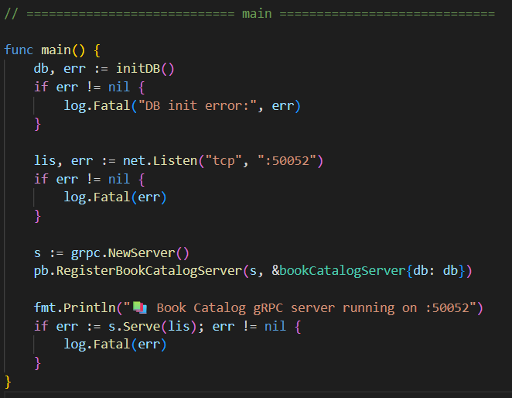
main starts the Book Catalog gRPC server.
- Initializes the database using initDB, logging a fatal error if it fails.
- Creates a TCP listener on port 50052 for incoming gRPC connections.
- Instantiates a new gRPC server and registers bookCatalogServer with the database connection.
- Prints a startup message and begins serving, blocking indefinitely until the server stops or an error occurs.

Client:
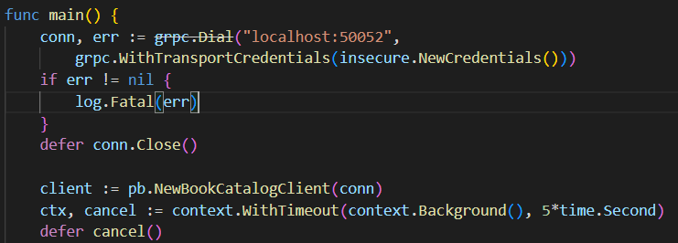
- Connects to localhost:50052 using an insecure channel.
- Creates a BookCatalog client stub with a 5-second timeout context.
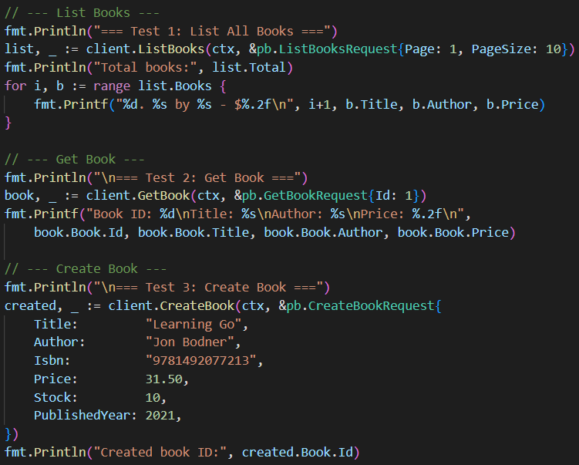
- Calls ListBooks (page 1, 10 items) and prints total books and a numbered list of title, author, and price.
- Calls GetBook for ID=1 and prints detailed info (ID, title, author, price).
- Calls CreateBook with book details; prints the server-generated ID.
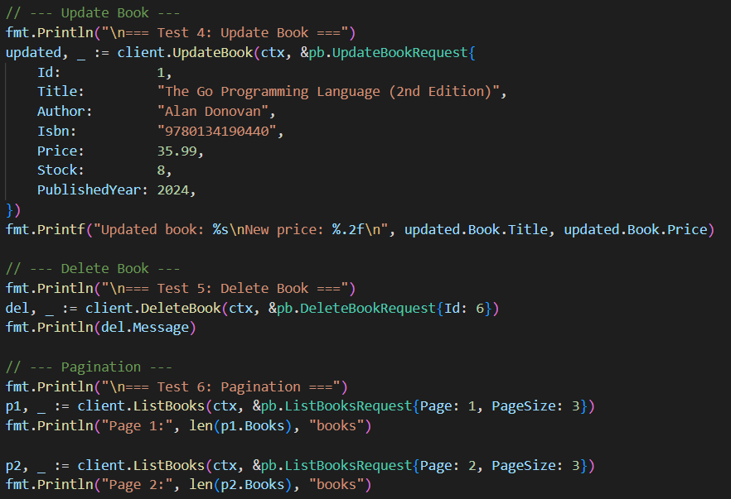
- Calls UpdateBook for ID=1 with new values; prints updated title and price.
- Calls DeleteBook for ID=6; prints the server message (deleted successfully or not found).
- Calls ListBooks with page size 3 for pages 1 and 2; prints number of books returned to demonstrate pagination.
Output:
Server:
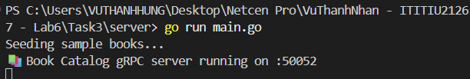
Client:
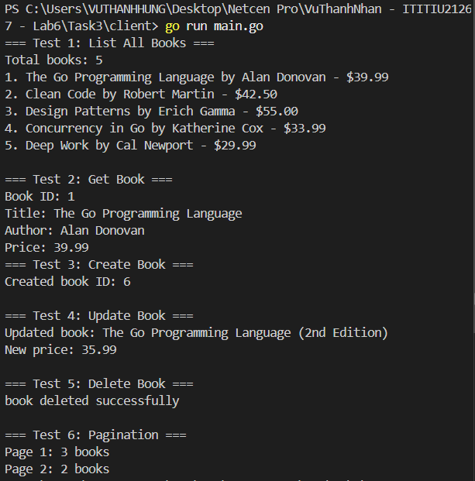
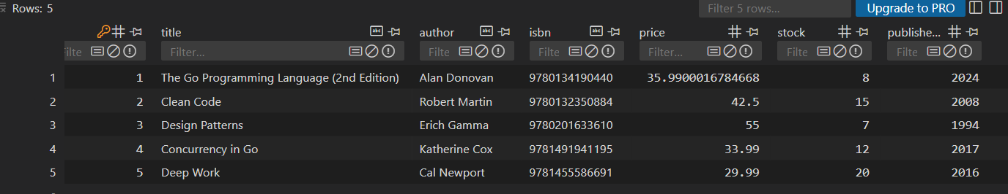

Task 4:
Server:
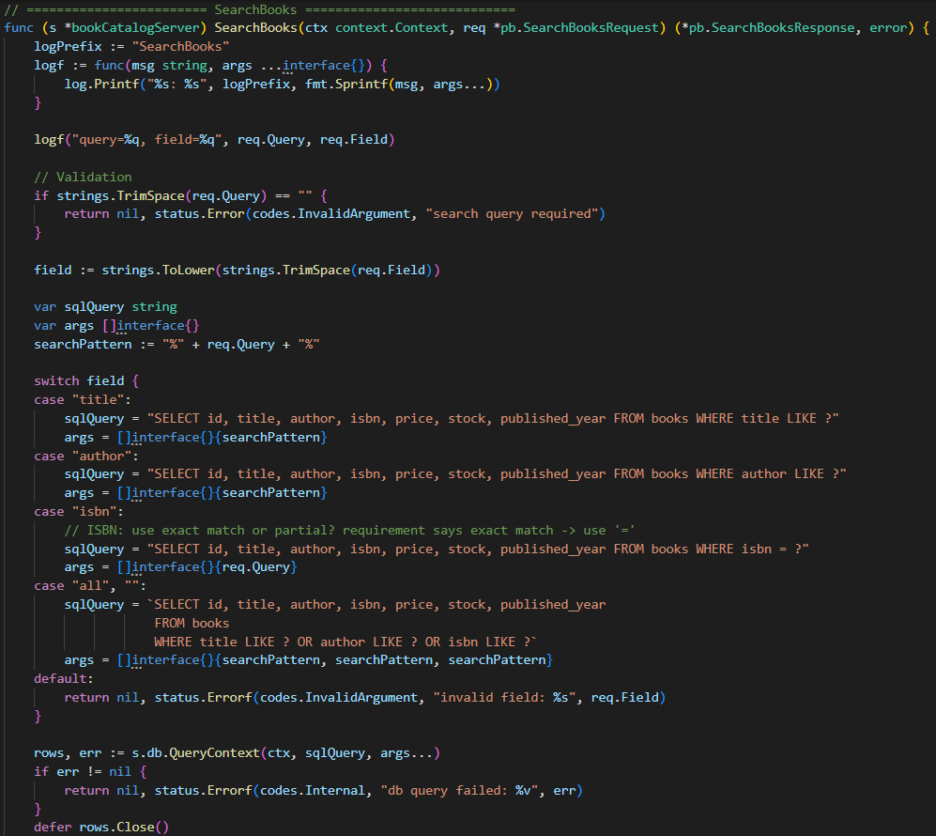
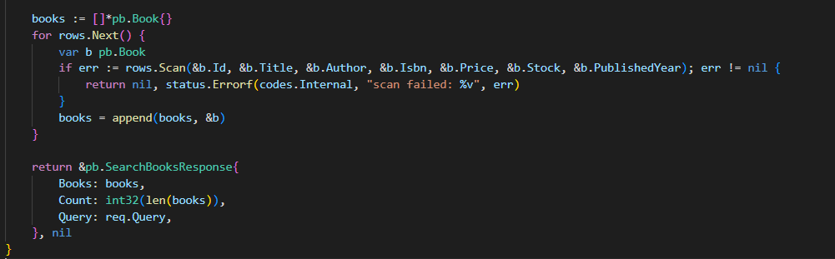
SearchBooks – Full-Text Search
- SearchBooks allows searching books by different fields (title, author, isbn, or all).
- Starts with a custom logging function to print the query and field for easy tracking.
- Validates input: query cannot be empty, and field is normalized to lowercase for case-insensitive comparison.
- Builds a dynamic SQL query based on the field: title and author use LIKE with %, isbn uses exact match, all or empty searches all fields; invalid fields return an error.
- Executes the query, scans results into Book structs, handling scan errors properly.
- Returns SearchBooksResponse containing the matched books, count, and original query for confirmation.
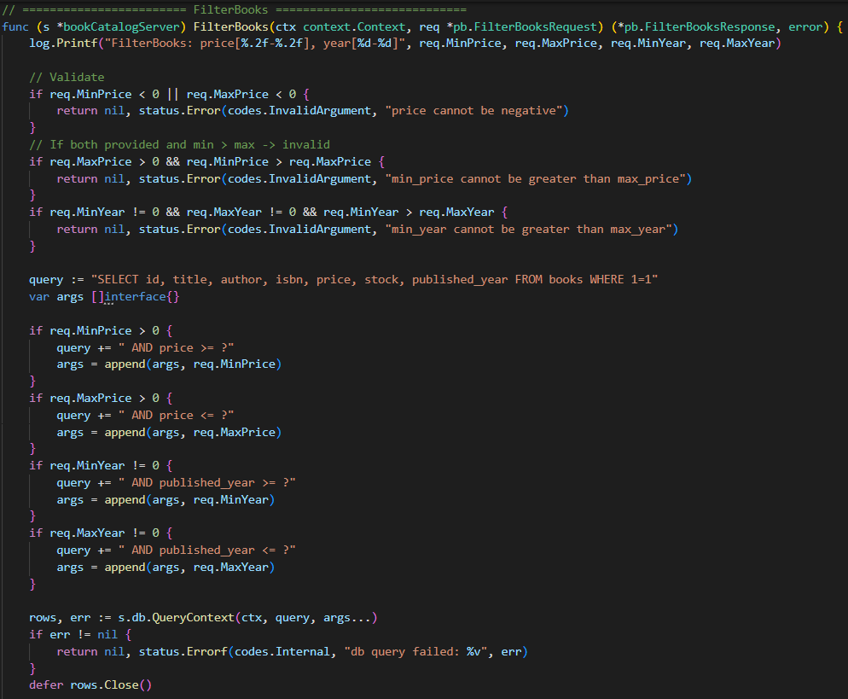
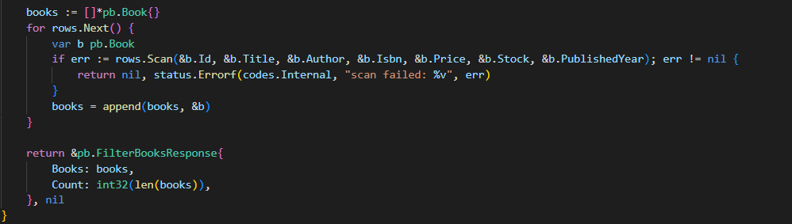
FilterBooks – Range-Based Filtering
- FilterBooks filters books by price range (MinPrice–MaxPrice) and/or publication year (MinYear–MaxYear).
- Logs filter criteria for debugging.
- Validates inputs: prices and years cannot be negative, min cannot exceed max when both are provided.
- Builds a dynamic SQL query starting with WHERE 1=1 and appends conditions for price and year only if values are provided.
- Executes the query, scans results into Book structs, handling errors properly.
- Returns FilterBooksResponse containing filtered books and count.
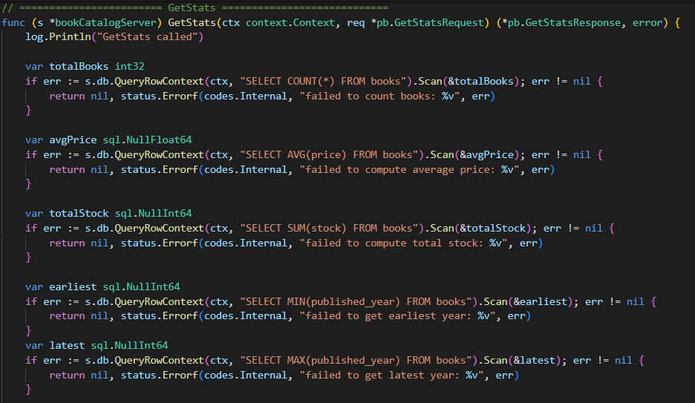
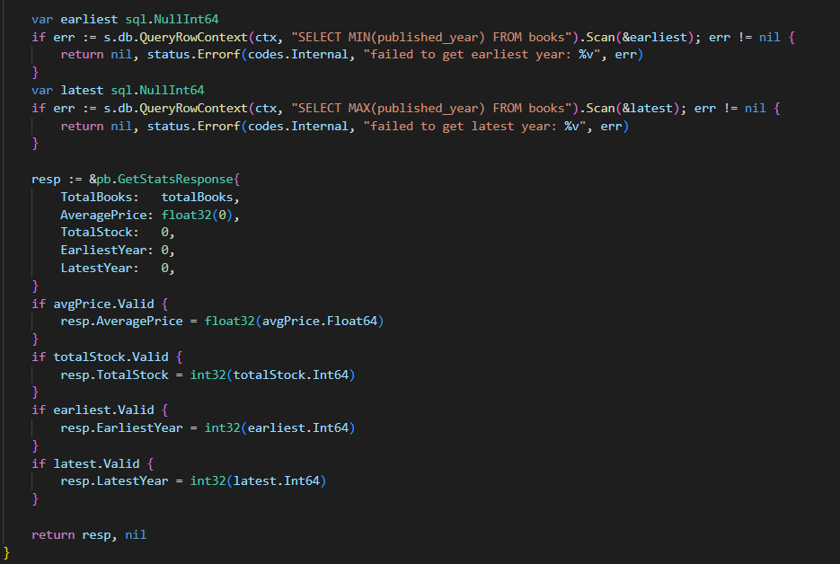
GetStats – Aggregate Statistics
- GetStats computes aggregate statistics about the book collection.
- Retrieves total book count using COUNT(*).
- Computes average price and total stock using AVG(price) and SUM(stock) with sql.NullFloat64/sql.NullInt64 to handle NULLs when the table is empty.
- Finds the earliest and latest publication year with MIN and MAX, handling NULLs.
- Builds the response with safe defaults (0) and sets values only if valid, ensuring proper type conversions for protobuf.
- Returns GetStatsResponse containing total books, average price, total stock, earliest year, and latest year.

Client:
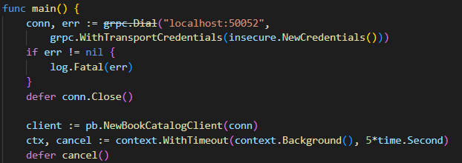
- Connects to localhost:50052 using an insecure credentials.
- Creates a BookCatalog client stub with a 5-second timeout context.
- Executes six test scenarios
Helper functions:
- searchAndCount – Searches books by field and prints count and titles.
- searchError – Searches books and prints any gRPC errors.
- filterAndCount – Filters books by price/year and prints count.
- filterError – Filters books and prints any gRPC errors.
- doStats – Retrieves and prints aggregate book statistics.
- printGrpcError – Prints gRPC errors in a readable format.

Output:
Server:
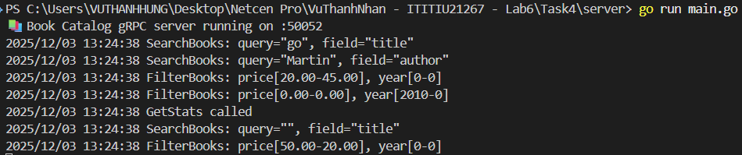
Client:
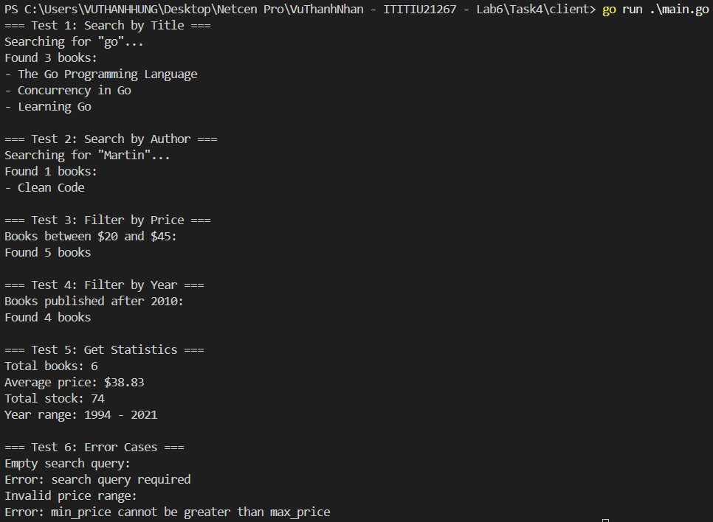

Task 5:
Book Service:
author_id (Foreign key linking book to author) added to SELECT and Scan
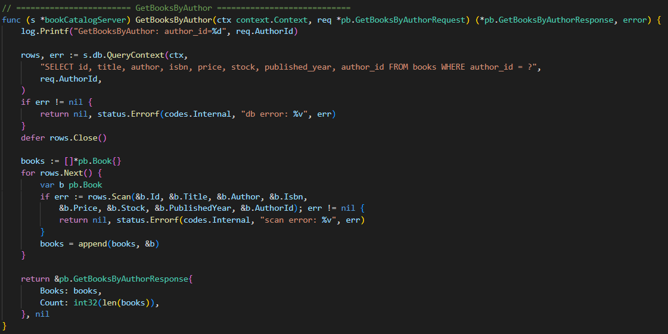
- GetBooksByAuthor serves as an internal endpoint for other services (e.g., Author Service) to retrieve all books linked to a specific author_id.
- It logs the request, queries the database for all rows where author_id = ?, and iterates through the results, scanning each into a Book struct.
- All matching books are collected into a list, and the method returns a GetBooksByAuthorResponse containing the books and their total count.
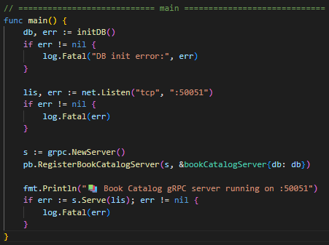
- Initializes the database via initDB() and exits on failure.
- Opens a TCP listener on port :50051.
- Creates a gRPC server and registers the BookCatalog service with the database instance.

Author Service:
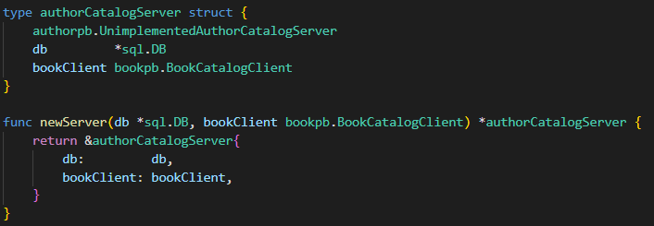
- bookClient: gRPC client to communicate with Book Service.
- Dependency injection pattern: Client is passed in during server creation.
- Constructor function that accepts both dependencies and clean way to initialize the server with injected dependencies.
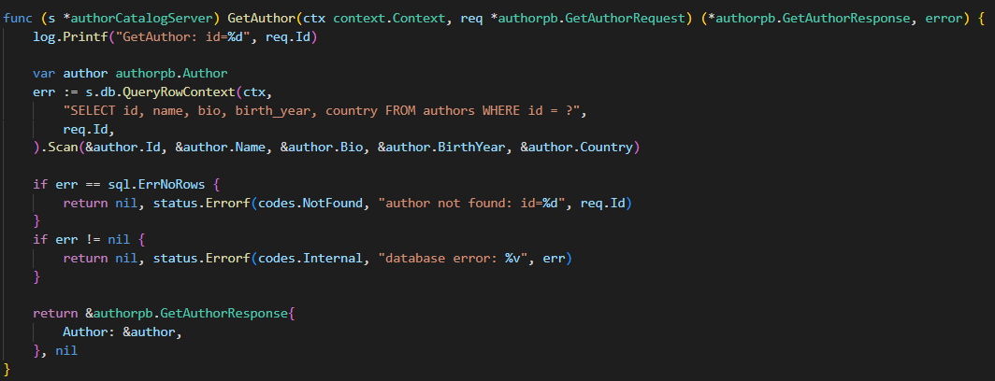
GetAuthor
- Log incoming request.
- Execute SELECT query to fetch author by ID.
- Scan result into Author struct.
- Return NotFound error if no row exists.
- Return internal error for other DB issues.
- Return GetAuthorResponse with the author if successful.

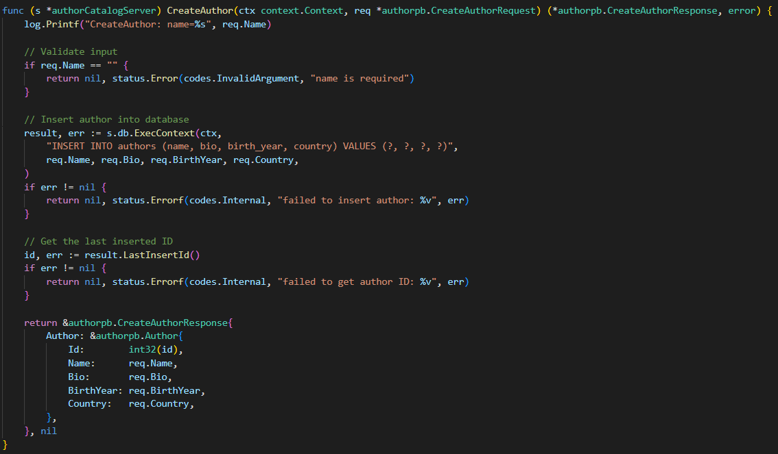
CreateAuthor
- Validate that name field is not empty.
- Execute INSERT statement into authors table.
- Retrieve auto-generated ID from the DB.
- Construct Author object with new ID.
- Return response containing the created author.

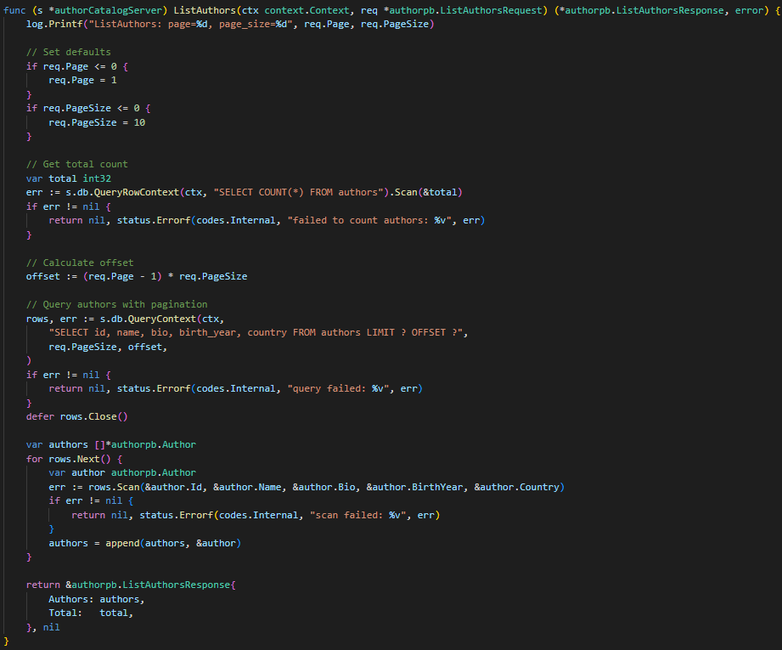
ListAuthors (Pagination)
- Log request and apply default page and page_size.
- Query total number of authors to calculate pagination.
- Compute offset based on current page.
- Fetch authors using LIMIT + OFFSET.
- Scan each row into Author struct.
- Return paginated list plus total count.

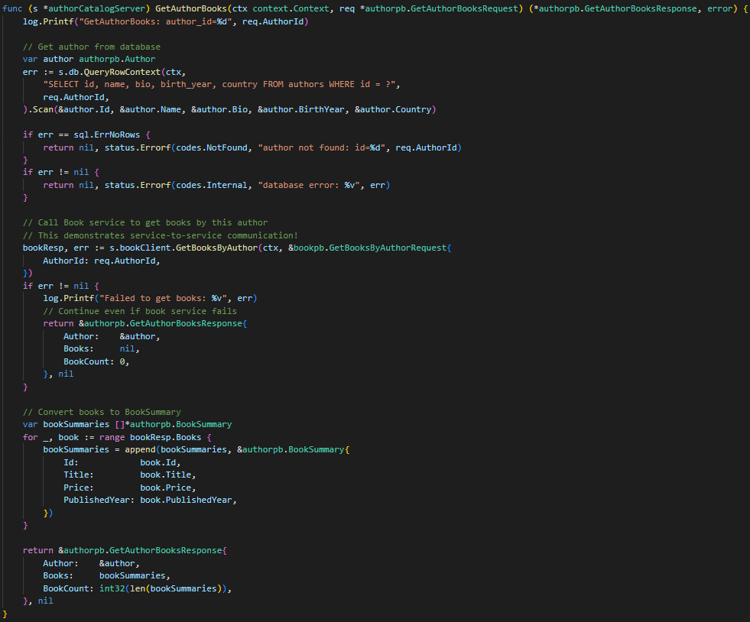
GetAuthorBooks – Cross-Service Communication
- Check local DB to confirm the author exists.
- Return NotFound if missing.
- Call Book Service via gRPC (GetBooksByAuthor) with the same context.
- If Book Service fails: degrade gracefully → return author with empty book list.
- If successful: convert returned books into lightweight BookSummary objects.
- Combine author info + book summaries into one unified response.

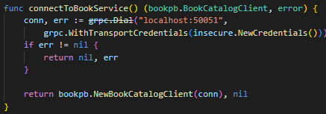
- connectToBookService establishes gRPC connection to Book Service at port 50051.
- Uses insecure credentials for internal communication.
- Connection stays open for the Author Service lifetime.
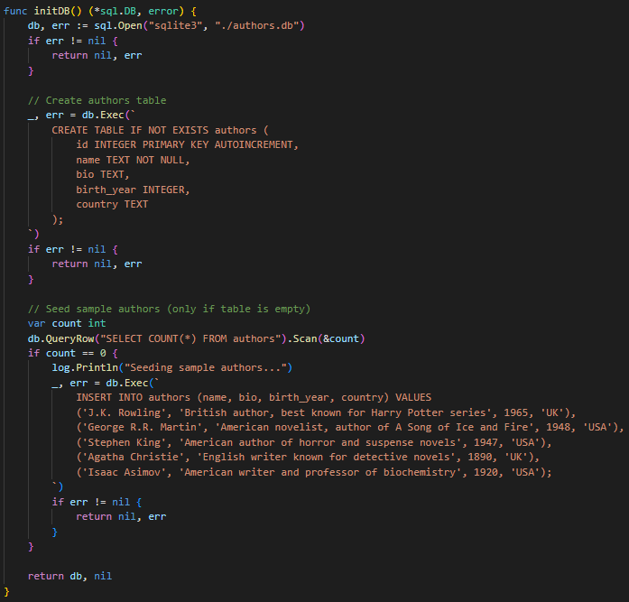
- initDB opens or creates authors.db.
- Ensures authors table exists.
- Seeds five famous authors if table is empty.
- Follows database-per-service pattern: each service manages its own schema/data.

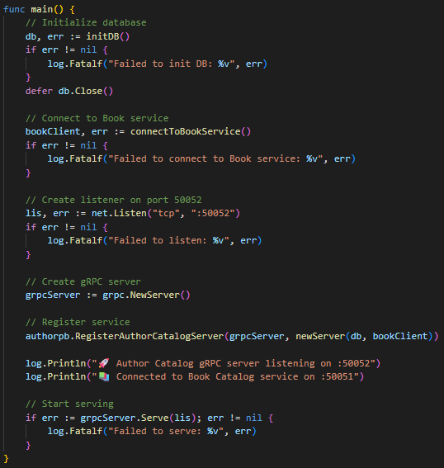
- Initialize database via initDB.
- Connect to Book Service.
- Listen on port 50052.
- Create and run gRPC server.
- Register Author Catalog service with DB handle + Book Service client.
- Log key startup steps for clarity and debugging.

Output:
Book Service:
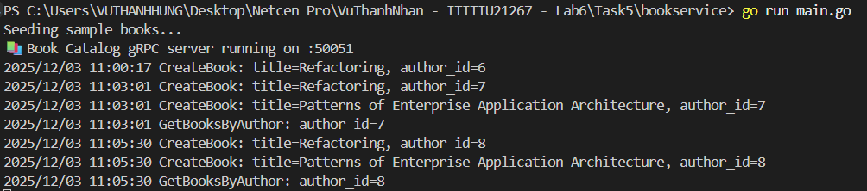
Author Service:
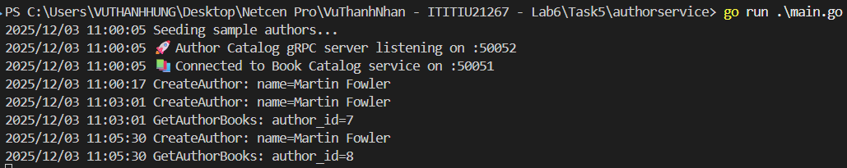
Client:
